Community Power Worldwide
The symposium‘s afternoon sessions widened the perspective on Community Power and Community Wind to the global scale. International experts from Australia, Belgium, Algeria, Cameroon, Canada, Denmark, Japan, Mali, Mexico, Chile, France, Morocco, and Zimbabwe discussed international developments, starting with the challenges as identified in the German case.
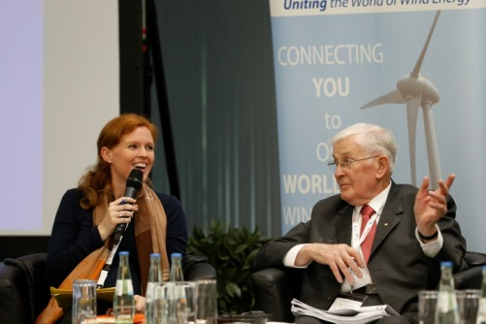
Stephanie Weckend (IRENA) chaired the “world-trip” that comprised perspectives on the framework conditions, drivers and barriers for Community Power projects in six countries. It was noted that without the community level involvement in building the energy systems of the future, serious national climate change action will not be possible. Local governments have therefore a unique responsibility to facilitate the energy revolution by providing communities with the frameworks and support in building local sustainable energy infrastructure. The participants identified regulatory/policy barriers as well as financial and cultural barriers. In addition the experts have also found the lack of clarity of the definition to be a problem.
Weckend (IRENA) and Rae (WWEA)
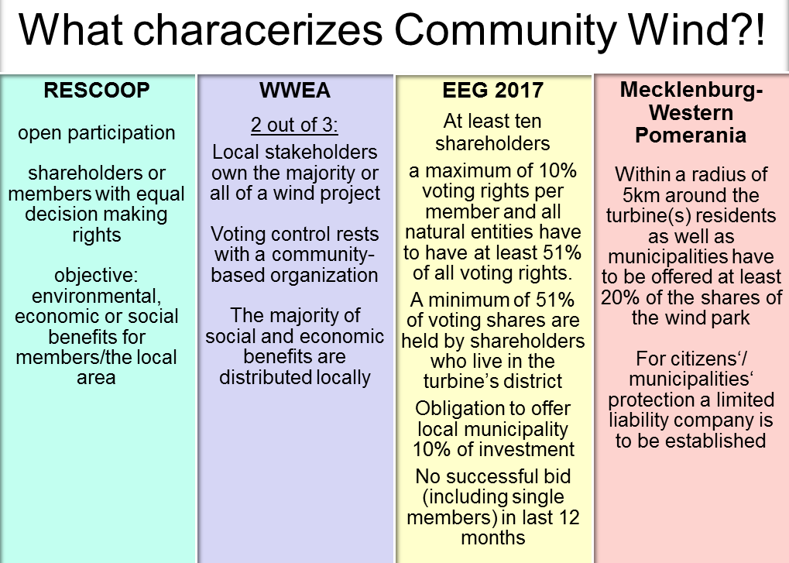
Figure 23: Examples of different approaches to a definition of community energy

